JABBER Version 11.9.3

Once Jabber is installed on your PC, these are the steps to follow to set it up.

Step 1

Enter your username@corp.toronto.ca Ie: sjohnso@corp.toronto.ca and hit continue, use OES ID, not long version. Leave it and go to step 2
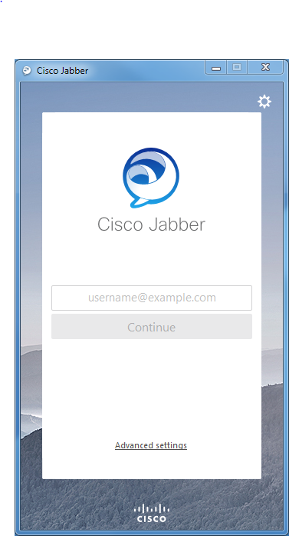

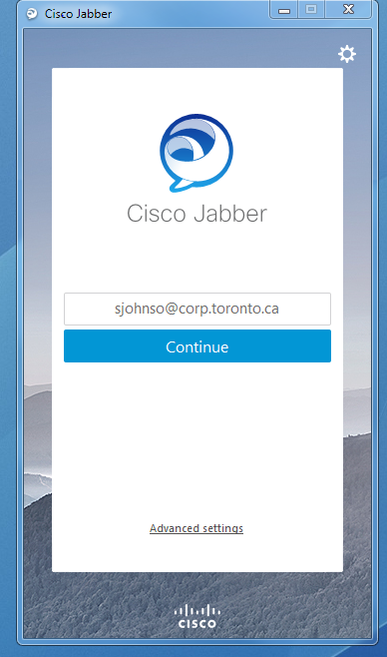

Step 2

Enter your username@toronto.ca (not your full name email address) and OES ID password and hit sign in. You are in Jabber and need to create a folder ie: City and start adding your contacts.

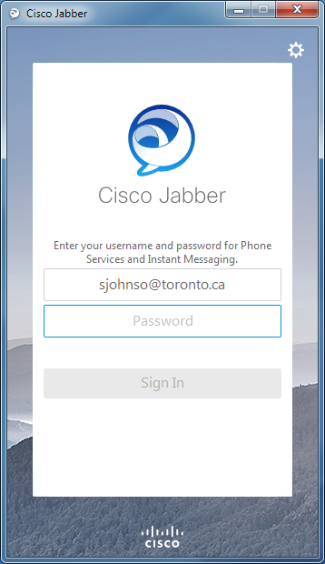
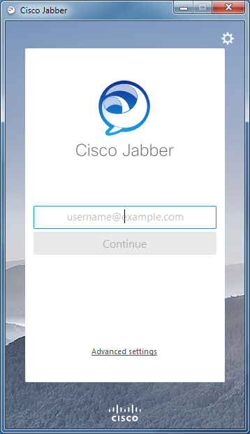

1. How many users can be in a group chat together? (IM) – can it support around 100? Any network/bandwidth issue?
You can invite around 100 participants to the group chat. You can invite participants to the group chat in one of the following ways:
https://help.webex.com/en-us/n1vljz2/Start-a-Group-Chat-in-Cisco-Jabber
2. How many users can you share your screen to at once? – i.e. if you’re in a group chat and then select Share Sc
Cisco Jabber users can share their screen with 5 Cisco Jabber for Windows users in a group chat. All client versions must be 10.5 or later
https://help.webex.com/article/en-us/WBX89594
The links above seems to be broken, but as a confirmation I find the following information in the release notes of Jabber 10.5:
Users can share their screens from IM with up to five other Cisco Jabber for Windows 10.5 users in a group chat.
https://www.cisco.com/c/en/us/td/docs/voice_ip_comm/jabber/Windows/10_5/rn/JABW_BK_J559CFFB_00_jabber-windows-release-notes-10-5/JABW_BK_J559CFFB_00_jabber-windows-release-notes-10-5_chapter_00.html

